Entry Form for

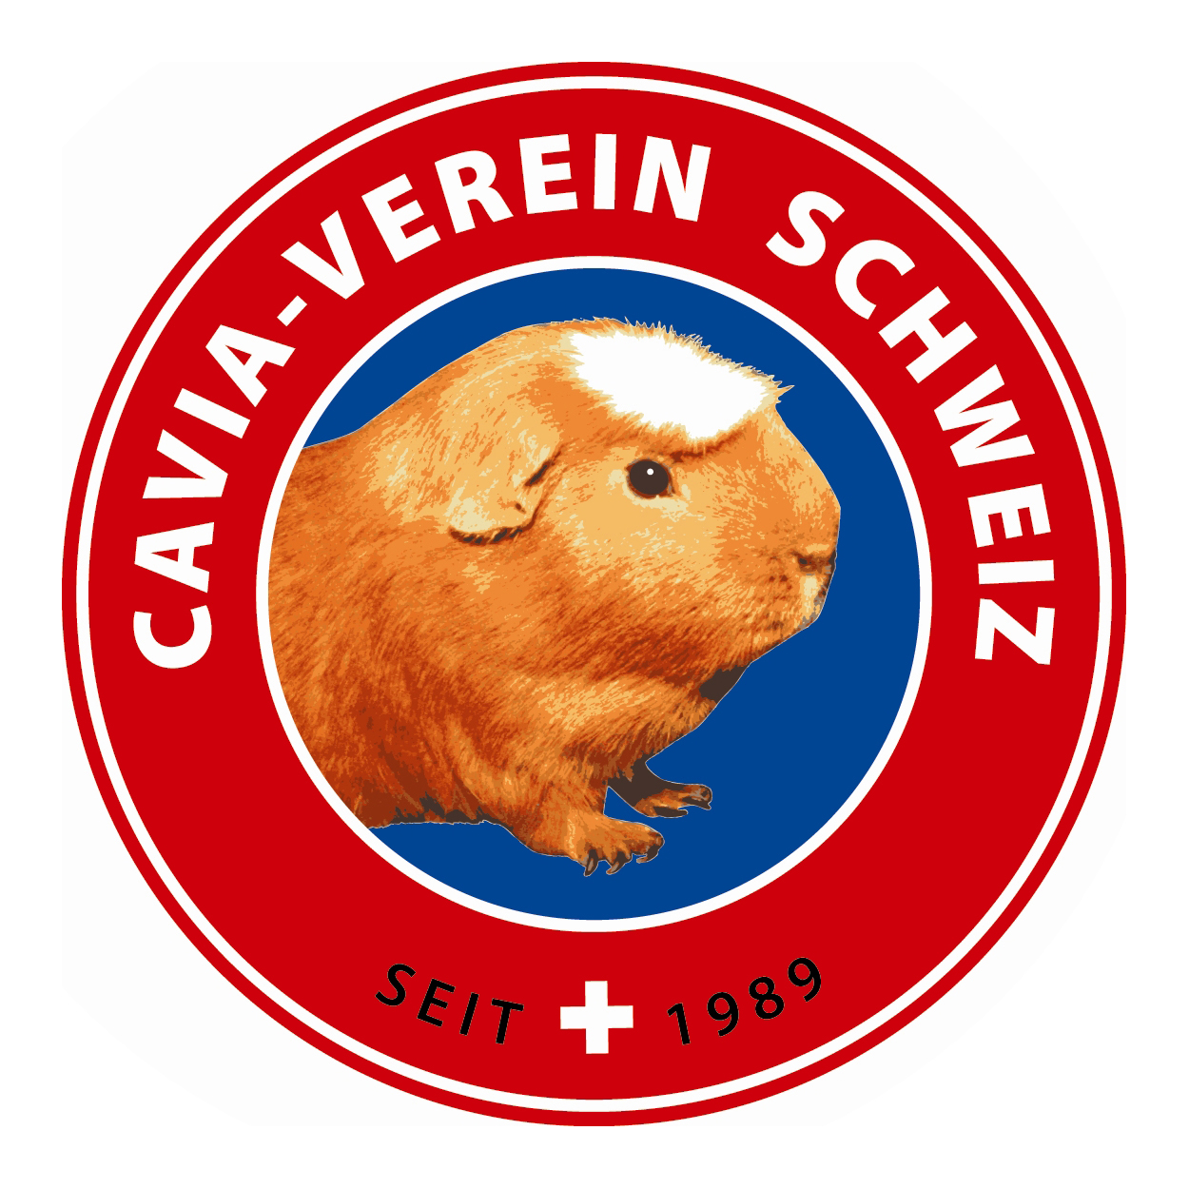
Open Pet Show

14./15. May 2011 4554 Etziken SO

Name + Christian name

Street, Postcode + Town/Country

Tel. and Email

I would like to assist as a helper: Booksteward / Steward /Feeding / Info/ Sale section…

Pet - resembling the breed: | Colour | M/F | Age  A/B/C | Pen nr.  Sec’s use
A-class = from 10 months +, B-class 5-9 months, C-class 3-5 months / M = male (boar) / F = female (sow)

I reserve | ... | Sale pens | Entry fees’ totals
…. .. exhibits à € 3.50 / Fr. 5.30 |  |  |  | € |  | Fr.
………..Sale stock à € 2.00 / Fr. 3.00 |  |  |  | € |  | Fr.
Administration fee incl. souvenir |  |  |  | € | 8.00 | Fr. | 12.00
Catalogue obligatory (1 per household) |  |  |  | € | 4.00 | Fr. | 6.00
x Social evening with banquet à € 25.00 / Fr. 38.00 |  |  |  | € |  | Fr.
Breeders’ adverts à € 20.00-60.00 Fr. 30.00/ 90.00 |  |  |  | € |  | Fr.
Total |  |  |  | € |  | Fr.

All fees have to be transferred by 5. April 2011 to Euro account number:
61355.29 IBAN Nr. CH71 8097 1000 0061 3552 9 / EUR, SWIFT RAIFCH22
or CHFr-account 61355.23 Cavia-Verein Schweiz.

Town and date. Signature................

All entries (please write in block capitals or type) to be received by 01. April 2011:
Rösli Karpf, Hinterwilerweg 110, CH 4714 Aedermannsdorf
Or attached to an email to: roesli.karpf@sunrise.ch (only accepted after confirmation of receipt)

